Load anaconda powershell prompt

(base) PS C:\Users\Jeff> conda activate facemap

(facemap) PS C:\Users\Jeff>

(facemap) PS C:\Users\Jeff> python -m facemap

The above command opens the GUI for facemap.

File

Load Single Movie File (select to .mp4 file from the session you want to analyze)

Select pupil for ROI

Add ROI

Add corneal reflection

Change saturation so that the pupil is clearly outlined. Check during periods of movement to make sure that the pupil is clearly tracked and is not lost.

Click Save ROIs (will save a file *-VT1_proc)

Pupil is saved as pupil{1,1}.com(:,2))

Example mask for blink

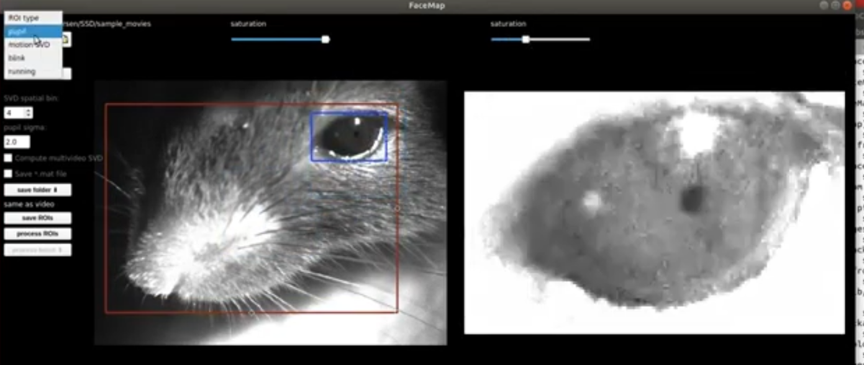

Example mask for pupil

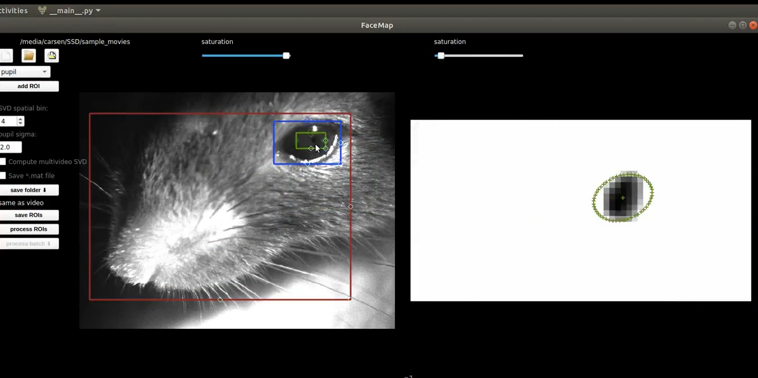

Click “Process ROIs” when everything is ready. Processing will take awhile, between 5 and 15 minutes. If there is an error that python throws, its usually b/c the pupil went off the screen. In that case, you may have to change the size/position of the boundary ellipses (“masks”).

Once processing is finished, you can view the traces of motion SVD, blink, and pupil by clicking on the check boxes at the bottom. In particular, you can se the x position (horizontal), y position (vertical), and pupil area over time.

In matlab, run detectSaccadesManualCheck6([]);. This will open a window with the eye velocity trace, an AHV trace, the filtered eye velocity trace (which helps detect jumps/skips/erroneous events), the +- threshold, and putative saccade events (temporal saccades in red, and nasal saccades in green).

Work your way through the matlab prompts. Press enter to advance to the next step. Crosshairs should appear for you to manually select a saccade event. Press enter after clicking as many saccades as you want to select. Scroll through the session by swiping with the mouse. Select ‘y’ to enter more saccades manually. New Saccades will appear as soon as you press enter. To remove erroneous saccades, press the ‘r’ button with the crosshairs instead of clicking the mouse. Saccades selected for removal should now have red circles surrounding them. The program is glitchy and sometimes selecting a saccade for removal will also select an adjacent saccade for removal. You may have to scroll through the session twice, and re-enter some removed saccades.

When you are finished, matlab will have written a file with the SSN + ‘-saccades-edited.mat’. It will also create a ‘saccades-edited.fig’ figure showing you the same traces as above with all saccades events.

Run [STtstart, STtend, tlistX] = findSteadyPeriodsManual()

to manually isolate the epochs where the platform is stationary from when the platform is moving. The matlab window will display AHV and give prompts. Use the mouse to select the boundaries of platform-stationary periods.